Amazon Web Services

**Simple Storage Service**

# Simple Storage Service – S3

* S3 is a secure, durable, and highly scalable object storage.
* S3 is easy to use, with a simple web service interface to store and retrieve any amount of data from anywhere on the web.
* This means customers of all sizes and industries can use it to store and protect any amount of data for a range of use cases, such as websites, mobile applications, backup and restore, archive, enterprise applications, and big data analytics.

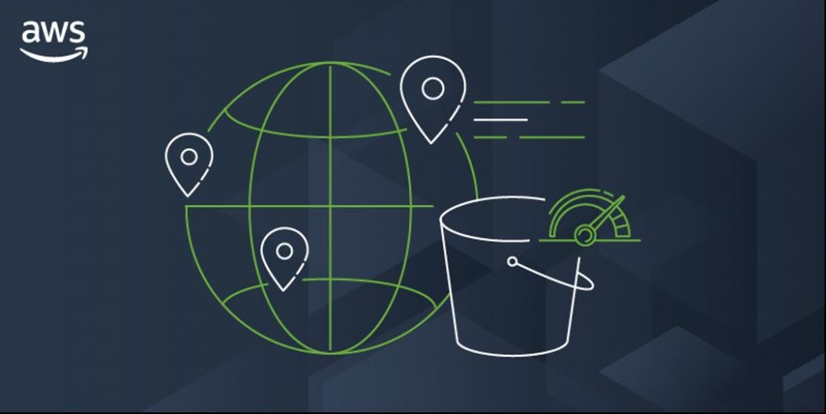

# S3 - Features

* It is a global service
* Low latency and high throughput performance
* It is a Safe place to store your files
* It is object-based storage
* Durability: AWS claims Amazon S3 to have a 99.999999999% of durability. This means the possibility of losing your data stored on S3 is one in a billion.
* A single Amazon S3 object can store a maximum of 5 terabytes.
* The total volume that an s3 bucket can store is unlimited. If an object size is greater than 5 gigabytes, you should consider multipart upload.
* S3 Bucket Names must be unique globally.
* Lifecycle Management
* Versioning
* Encryption
* Secure Your data using Access Control lists & Bucket Policy

# S3 - Restrictions and Limitations

* Bucket ownership is not transferable to another account.
* When we create a bucket, we choose its name and the AWS Region to create it in.
* After we create a bucket, we can't change its name or Region.
* By default, we can create up to 100 buckets in each of our AW’S accounts.
* If we need additional buckets, you can increase our account bucket limit to a maximum of 1,000 buckets by submitting a service limit increase.
* There is no difference in performance whether you use many buckets or just a few. (Note: Search Service Quotas in AWS)

# S3 - Priced

* Amazon Simple Storage Service (Amazon S3) is an elastically scalable object storage service. The service provides a free tier to get you started, with limited capacity for 12 months.
* **Storage Tiers**: AWS S3 prices per GB-month of storage, and pricing varies according to the storage tier you select. The AWS S3 Standard tier provides instant access with low data retrieval costs, but a relatively high cost per GB. There are lower cost tiers that offer lower cost per GB, but higher cost of data retrieval or delayed data retrieval.
* **Cost per requests**: AWS S3 has a cost per 1,000 requests, depending on the request type.
* **Data Transfer**: There are extra charges for data transfer from AWS S3 to the Internet, or to certain AWS regions.
* **Management and analytics**: AWS S3 charges extra for automating the data lifecycle and moving data automatically to the most optimal storage tiers.
* **Replication**: if you set up replication in AWS S3, data transfer and operations

performed during replication are charged like regular AWS S3 operations.

# S3 - Overview of Buckets

* Amazon S3 Allows people to store objects (Files) in the

“buckets” (Directories)

* Buckets must have globally unique names
* Buckets are defined at the region level
* Naming Convention
* No Uppercase
* No Underscore
* 3 – 63 Characters long
* Not an IP Address (224.245.278.135)
* Must start with a lowercase letter or number

# S3 – Create Bucket

* Click on Create Bucket
* Enter the bucket name
* Select the region
* Select ACLs Enabled
* Uncheck the block all public access
* Check the acknowledge
* Click on Create bucket

# S3 - Upload Object

* Click on the name of the bucket
* Click on Upload
* Click on Add files
* Select the file which we want to upload in our S3 bucket
* Click on permissions
* Select grant public read access
* Click on Upload

# S3 - View Object

* Click on the name of the object
* Go to the properties tab
* Copy the object URL
* Paste in the browser
* Change permission of the object
* Click on the name of the object
* Go to Permission tab

# S3 - View Object

* Click on Edit
* Uncheck read access from public access
* Click on save changes
* Paste the object URL in browser